Practical No: 9

Date Of Performance: 12/02/2025

Aim: Network Simulation Using Cisco Packet Tracer.

Lab Objectives:

The objective of this lab is to equip students with practical skills in designing,

configuring, and troubleshooting computer networks using Cisco Packet Tracer.

Students will learn to create network topologies, assign IP addresses, implement

routing protocols (RIP, OSPF, EIGRP), configure VLANs, and integrate essential

services like DHCP and DNS. The lab also focuses on simulating real-world scenarios, analysing packet flow, and using troubleshooting tools (ping, tracert, and show commands) to diagnose network issues.

Lab Outcomes:

By the end of the lab, students will be able to design functional network topologies, configure devices using Cisco CLI, implement routing protocols and VLANs, apply basic network security measures, and integrate core network services. They will also develop the ability to analyse network behaviour, troubleshoot common issues, and optimize network performance within a simulated environment, preparing them for real-world networking tasks and certifications like CCNA.

Theory:

Cisco Packet Tracer as the name suggests, is a tool built by Cisco. This tool provides a network simulation to practice simple and complex networks. The main purpose of Cisco Packet Tracer is to help students learn the principles of networking with hands-on experience as well as develop Cisco technology specific skills. Since the protocols are implemented in software only method, this tool cannot replace the hardware Routers or Switches. Interestingly, this tool does not only include Cisco products but also many more networking devices.

Using this tool is widely encouraged as it is part of the curriculum like CCNA, CCENT where Faculties use Packet Trace to demonstrate technical concepts and networking systems. Students’ complete assignments using this tool, working on their own or in teams. Engineers prefer to test any protocols on Cisco Packet Tracer before implementing them. Also, Engineers who would like to deploy any change in the production network prefer to use Cisco Packet Tracer to first test the required changes and proceed to deploy if and only if everything is working as expected. This makes the job easier for Engineers allowing them to add or remove simulated network devices, with a Command line interface and a drag and drop user interface.

Workspace:

**Logical** – Logical workspace shows the logical network topology of the network

the user has built. It represents the placing, connecting and clustering virtual

network devices.

**Physical** – Physical workspace shows the graphical physical dimension of the

logical network. It depicts the scale and placement in how network devices such as

routers, switches and hosts would look in a real environment. It also provides

geographical representation of networks, including multiple buildings, cities and

wiring closets.

Key Features:

* Unlimited devices
* E-learning
* Customize single/multi user activities
* Interactive Environment
* Visualizing Networks
* Real-time mode and Simulation mode
* Self-paced
* Supports majority of networking protocols
* International language support
* Cross platform compatibility

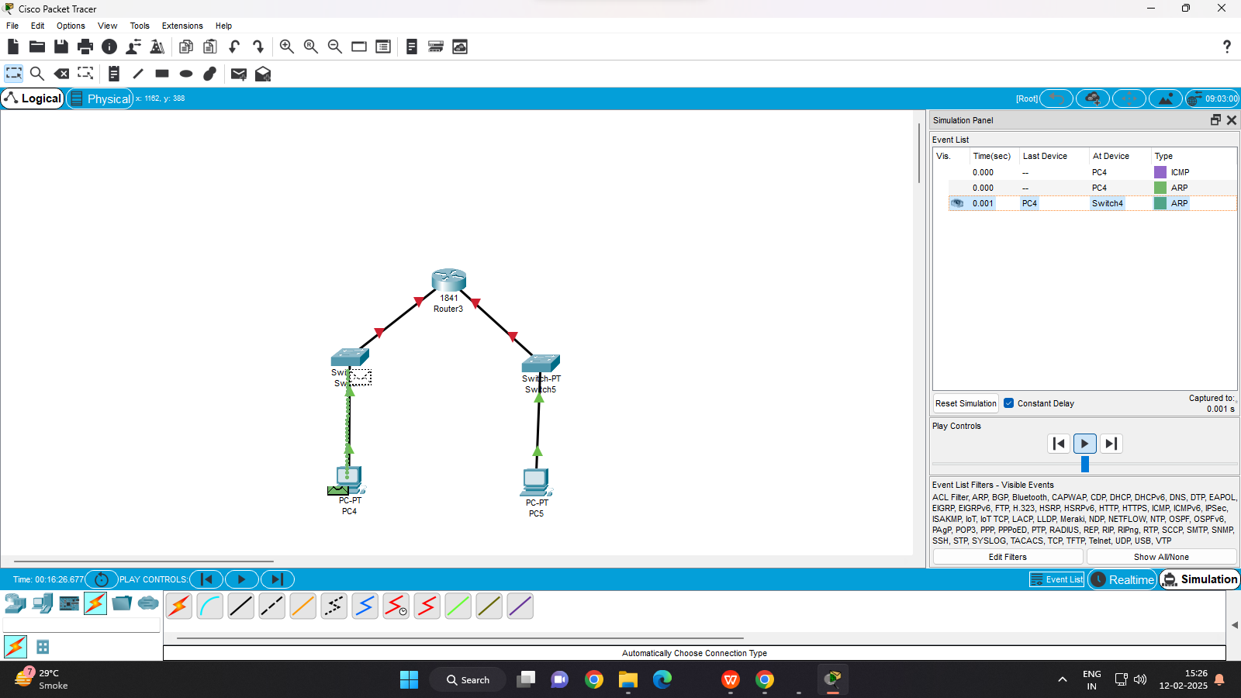

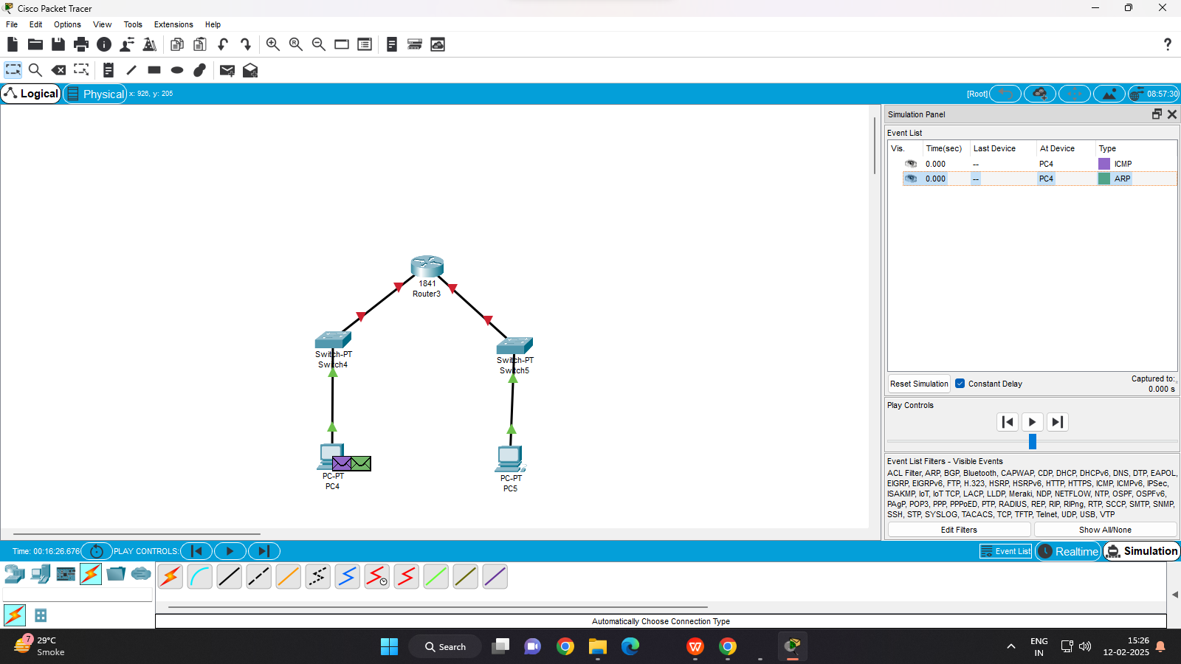

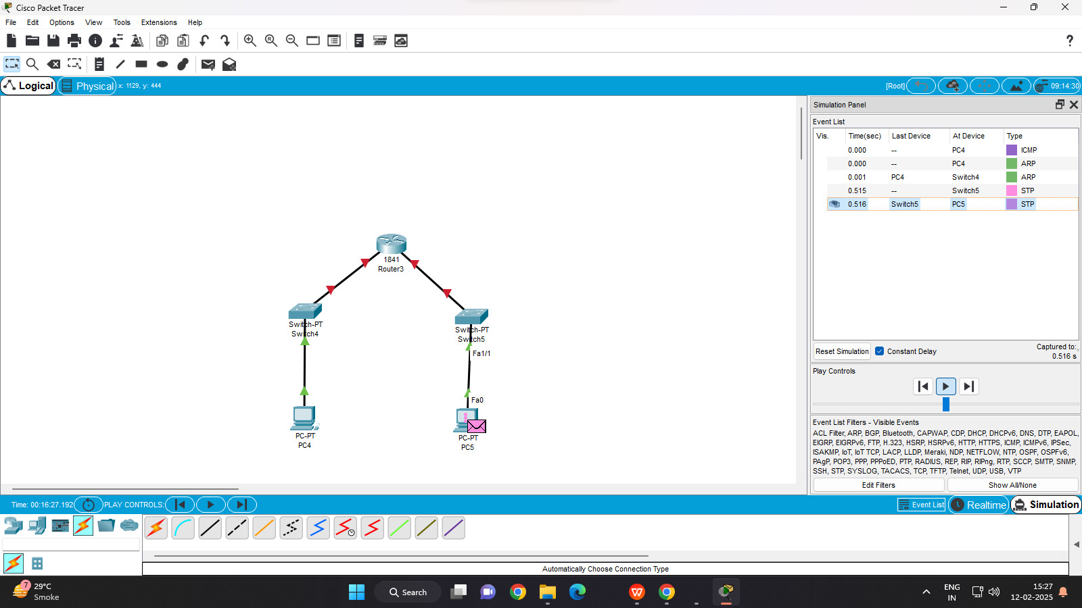

Conclusion:

We configured Cisco Packet Tracer on Windows 10 and simulated network scenarios. This allowed us to analyse performance metrics, packet flow, and network behaviour, enhancing our understanding of network simulation and Packet Tracer’s role in network design and performance evaluation.

|  |  |  |  |  |  |
| --- | --- | --- | --- | --- | --- |
| Performance  (7M) | Journal  (3M) | Lab Ethics  (2M) | Attendance  (3M) | Total  (15M) | Faculty Signature |
|  |  |  |  |  |  |